A
Very thoughtful and interesting paper!

No-Fault Divorce and Its Effects:
Review of the Economic Research
and an Analysis of the Law

Nice Title!

Lauren Blake and Zlata Hajro
Professor Witte
Economics 325
December 5, 2002

- Abstract

- Introduction

- Literature Survey
  - Becker (1977)
  - Peters (1986)
  - Brinig & Buckley (1998)
  - Allen (1999)
  - Friedberg (1998)
  - Zelder (1993)
  - Allen (1998)

- Presentation of Empirical Evidence
  - Peters (1986)
  - Zelder (1993)
  - Brinig & Buckley (1998)
  - Friedberg (1998)

- Discussion of No-Fault Divorce Debate
  - Efficiency and Equity Analysis of No-Fault Divorce
  - Other Effect of No-Fault Divorce
    - Reduced welfare of women and children

- Conclusion
  - Considering all presented evidence, make suggestions for divorce law reform.

- Bibliography

- Appendix

I. Abstract

Since the introduction of no-fault divorce law in 1968 there has been an upward trend in divorce rates in the United States. This trend has attracted great attention from both economists and lawyers who have contributed to the debate on whether no-fault divorce law was economically and socially desirable. Vast amount of literature on no-fault indicates that this reform in divorce law has led to an increase in divorce rates and a significant decline in economic well-being of women and children. For these reasons, there have been suggestions to reform the divorce law in the United States. This study reviews the evidence and literature and proposes reforms to increase the efficiency, equity and fairness of no-fault divorce law.

II. Introduction

Introduced in 1969, no-fault divorce law marks the liberalization of family law in the United States. Prior to this period, marriage dissolution required proof that one party breached the marriage contract by committing a ‘fault’ such as cruelty, adultery or insanity. The groundbreaking nature of no-fault divorce law was the elimination of the proof requirement. Under no-fault law a divorce can be granted as long as the marriage is shown to be “irretrievably broken”. This new law also made it possible for one spouse to decide to divorce unilaterally, as opposed to the required consent of both spouses that existed under the fault law. Further, Douglas Allen, a leading economist in the field of divorce law research, suggests that the adoption of no-fault divorce law transferred the power of divorce decision making from the person least wanting the divorce to the person most wanting the divorce. Interesting.
Divorce rates in the United States have doubled since the introduction of no-fault in the early 1970s. This raised an important debate as to whether no-fault law was to blame for such an increase. The substantial amount of literature written on this specific question must be classified into two different time periods, namely that before and after 1986. Research conducted prior to 1986 shows no empirical relationship between no-fault law and changes in divorce rates. Demonstrating quite the opposite, studies done after 1986, which were enhanced with the improvements in economic data and methods, provide empirical evidence that no-fault divorce law is actually positively correlated with divorce rates. Interesting, this was a year of major tax reform.
No-fault divorce law is an important topic that has its origins in both law and economics. Laws have important impact on economic decisions of individuals. No-fault divorce law is associated with lower transaction costs for exiting a marriage, by making it easier to file for a divorce and by eliminating the costs associated with proving who is at fault. This clearly creates an incentive for individuals to file for a divorce more when its costs are lower. Additionally, research has shown that no-fault law has had significant economic effects on the well-being of women and children.
In the next section of this paper, we provide a summary of the findings on the effects of no-fault divorce on divorce behavior. Consulting economic research from before and after 1986, this overview illuminates the complexities of the debate as to whether no-fault divorce laws have actually impacted the likelihood that marriages will end in divorce. In the fourth section, we present the empirical evidence from the leading research on no-fault divorce laws and the impact on divorce rates. These studies include the research of Peters (1986), Zelder (1993), Brinig and Buckley (1998), and Friedberg (1998). In the fifth section of our paper, we provide a discussion of the efficiency and equity considerations surrounding no-fault divorce. Moreover, we discuss effects of no-fault on the welfare of women and children. Finally, by considering the presented research on no-fault divorce law, we present possible alternatives and conclude our paper with a potential divorce law reform.

Figure 1: Literature Survey of the Effects of No-Fault Divorce

Study | Scope of the Study | Method of Analysis | Conclusion
Allen  (2002) | The effects of no-fault divorce law on divorce rate, labor force participation and age at which individuals marry. | Effects Analysis.  Looks at how no-fault divorce affects certain economic decisions of married individuals. | No-fault divorce raises divorce rates, increases the age of first time marriage and raises married women’s labor force participation.
Allen  (1998) | Why was no-fault divorce was adopted in the US, Canada, and Western Europe. | Efficiency analysis. Uses woman’s labor force participation to measure whether a marriage is efficient. If marriage is inefficient, no-fault is desirable. | No-fault divorce came about because of social changes and reflects the best solution in terms of efficiency.
Gordon (1998) | Should we change no-fault divorce law and impose more strict regulation? | Effects Analysis. Looks at the effect that no-fault has on welfare of children to assess whether current no-fault law should change or not | Better to live with problems of relatively unregulated private life than impose greater problems with strict regulation.
Parkman (1998) | Why the hours worked by married women have increased? | Effects Analysis.  Measure how hours worked have changed in states that have adopted no-fault divorce. | Increase in the total number of hours worked by married women in states after the adoption of no-fault divorce.
Ressler & Waters  (2000) | Becker’s economic  theory of divorce. | Simultaneous equation model to show how women’s earning ability influence divorce rates. | Female earnings have a positive effect on divorce but this effect has waned over time.
Becker et al.  (1977) | Theoretical justification for why the only divorces that occur are efficient divorces. | Efficiency analysis. Applying Coase’s theorem to both institutions of fault and no-fault divorce regimes. | A change in divorce law should have no effect on divorce rate.
Allen (1999) | Relationship between no-fault divorce and divorce rates. | Summary of the literature on the topic. Most studies mentioned use effects analysis. | No-fault has certainly led to an increase in divorce rates. Mutual divorce law would be a more efficient option than no-fault.

III. Literature Review
Gary Becker was one of the first to conduct economic research on the impact of no-fault divorce laws on divorce rates. In an article written in 1977, Becker et al. employed a Coasian argument to argue that the adoption of no-fault divorce had no effect on the rates of divorce. Based on Coase’s Theorem (1960), this conclusion was based on the assumption that transaction costs of a divorce were zero, which made bargaining between husband and wife non-problematic. If the hypothesized dollar value of both the husband’s and wife’s desire to stay married was greater than the sum of their individual desires to be single, the couple would remain married. This is considered an efficient marriage. If however, the sum of their individual desires to be single was greater than the combined value of their desire to remain married, this marriage would be said to be inefficient and they should divorce. Assuming zero transaction costs, the party that valued either separation or continuing the marriage the most would be able to bargain with the other party and arrive at a settlement that was mutually beneficial—which is efficient. Becker et al. further demonstrate that the outcome would always be efficient regardless of the fault regime. Depending on what each partner values, there is room for negotiating under both fault and no-fault law to make both parties better off by compensating the damaged party. Thus, they hold that only inefficient marriages end up in divorce and because the result of efficient bargaining is not affected by fault, the adoption of no-fault divorce law has no effect on the divorce rate.
A decade after Becker’s article, Elizabeth Peters (1986) published her infamous paper “Marriage and Divorce: Informational Constraints and Private Contracting”, which provided empirical support for Becker’s claim. This study became one the most debated studies on no-fault divorce. In this study, Peters presents empirical evidence on the impact of two different divorce laws on various aspects of marriage contract, the most important one being the probability of marriage dissolution. One law is no-fault, which specifies that either spouse can instigate divorce unilaterally. The other law requires that both spouses agree to divorce. Empirical results of the study show that divorce rates are not significantly different for no-fault states and states requiring mutual consent. This leads Peters to conclude that the probability of divorce does not depend on the type of the law regime used.
As a reaction to the research of Elizabeth Peters (1986), Margaret Brinig and F.H. Buckley (1998) in their paper “No-fault laws and at-fault people” investigated the validity of Peters’ claim that no-fault divorce law had no effect on divorce rates. In examining each U.S. state’s divorce law, Brinig and Buckley classified a state as a “no-fault state” only if no-fault was applied to both the marriage dissolution and property distribution procedures. It was unclear as to whether Peters used these criteria in her research. The authors state that it is only under their definition of a no-fault state, that the effects of the reform can accurately be assessed. Meaning, a response to no-fault law can only be accepted as evidence if the individual is responding to no-fault incentives in both the dissolution and property distribution processes. In this study, Brinig and Buckley found that divorce rates were positively and significantly correlated with no-fault divorce state laws. With their stringent assignment of fault and no-fault to states in their research, the authors claim that they provide “the strongest evidence to date that no-fault divorce laws are associated with higher divorce levels.”
Douglas Allen (1999) provides a broad overview of no-fault divorce law in his paper, “No-Fault Divorce and the Divorce Rate: Its History, Effects and Implications”. Allen’s study summarizes the historical origins of no-fault and the effects of no-fault divorce on divorce rates. Moreover, it mentions some important policy implications about the divorce law. Before looking at the effects of no-fault divorce law on divorce rates, Allen spends some time talking about the divorce theory using the economic efficiency approach. He looks at spouses’ utility and transaction costs of divorce, and tries to determine whether divorce is efficient or inefficient by comparing the two. Allen concludes that no-fault has certainly led to an increase in divorce rates over the past three decades. In his conclusion, he proposes a future shift towards a mutual divorce law. Mutual divorce law would eliminate inefficient divorces, since no party would be able to leave the marriage without the other’s consent. Move from Potential Pareto efficiency to Pareto efficiency. Moreover, both spouses would make investments in marriage without the fear that it would be destroyed or stolen by the unilateral departure of one spouse.
A recent study by Leora Friedberg (1998) is an attempt to find a definitive answer to the question whether unilateral divorce law affects divorce rates. She uses panel data that includes almost every divorce in the U.S. over the period of law reforms. With her empirical work, Friedberg estimates that without unilateral divorce, divorce rates would have been 6 percent lower in the states that adopted the law. Moreover, she finds that the unilateral divorce accounts for 17 percent of the overall increase in divorce rates in the period between 1968 and 1988. Friedberg also looks at different definitions of no-fault law. Her results suggest that the type of unilateral divorce that a state adopted mattered. The Friedberg study is claimed to be the best-known study that empirically confirms the positive correlation between no-fault divorce and divorce rates. By whom?
The following two studies identify the presence of inefficient and efficient divorces by looking at the changes in the law. The first one of them is a study done by Martin Zelder (1993). In “Inefficient Dissolutions as a Consequence of Public Goods: The Case of No-Fault Divorce”, Zelder looks at the relationship between no-fault law and divorce rates, by claiming that no-fault divorce increases divorce rates due to the nontransferability of children. Children are quasi-public good in a marriage and they cause inefficient bargain over divorce. When one spouse decides to end the marriage, the private transferable wealth of the other spouse is not sufficient to compensate the leaving spouse. The reason is the public-goods aspect of children: The presence of children within marriage makes a large fraction of each spouse’s gains to marriage nontransferable. As the result, divorce will occur even if joint gains to marriage exist. Moreover, the spouse instigating divorce will gain more by being single than remaining married, and also will enjoy the benefits of the public good - children. In his conclusion, Zelder suggests that the law should not allow no-fault divorce except in the cases of couples without children. Yes, children certainly change things!
Adding to the discourse on no-fault divorce effects and efficiency is Douglas Allen (1998) and his analysis of Canada in “No-fault divorce in Canada: Its cause and effect”. While each state in the United States has a unique set of divorce laws making general study of its effects difficult (see Peters (1986) and Brinig & Buckley (1998)), Allen chose to study Canada because of the uniformity in the application of divorce law throughout the country. The results of his analysis demonstrate that the adoption of no-fault law did increase the number of divorces, most notably, inefficient divorces. How defined? However, he contends that women’s dynamic role in the workforce has destabilized the nature of marriage and has increased the possibility of inefficient marriages. Allen states, “Labor force participation on the part of women tends to increase the probability of divorce because it lowers the gains from marriage that are achieved by one spouse specializing in household production (133.)” Thus, no-fault divorce law, by reducing transaction costs of divorce, is beneficial because it reduces the barriers to dissolving inefficient unions. He argues that prior to Canada’s adoption of no-fault divorce in 1968, there were many inefficient marriages that existed because divorces were too costly or nearly impossible. As such, Allen predicts that the divorce rate in Canada will decrease over time, but still remain higher than it was prior to 1968.
Peters (1986) | How do unilateral and mutual consent-based divorce laws affect divorce rates? | Constructs two different models based on two laws and different assumption on information. | The probability of divorce doesn’t depend on the law regime.
Zelder (1993) | No-fault divorce law and its effects on divorce rates taking into the consideration the presence of children within marriage. | Effects Analysis. Uses ‘children’ variable and multiplies it with no-fault dummy variable to get inefficient divorces. | Due to ‘quasi-public good’ nature of children in marriage, bargaining leads to inefficient divorce. In the presence of children, no-fault leads to increase in divorce rates.
Brinig & Buckley  (1998) | Authors investigate whether the adoption of the no-fault divorce law in the United States has affected divorce rates. | Effects Analysis. Look at how the adoption of the law has changed the behavior of divorce filing in the U.S. | “Divorce levels are positively and significantly correlated throughout with no-fault laws.”
Friedberg  (1998) | “Revisits the evidence on the impact of unilateral divorce laws on divorce rates in the United States.” | Effects Analysis.  Uses a panel of state-level divorce rates (include virtually every divorce in the U.S. over the entire period of the law changes.) | Divorce rate would have been about 6 % lower if states had not switched to unilateral divorce.
Figure 2: Literature Survey of the Empirical Effects of No-Fault Divorce

IV. Empirical Evidence
Elizabeth Peters’ (1986) infamous paper “Marriage and Divorce Informational Constraints and Private Contracting”, became one the most debated studies on no-fault divorce. In this study, Peters presents empirical evidence on the impact of unilateral divorce laws on the probability of marriage dissolution. She constructs two models based on two different unilateral divorce laws, assuming different types of information. One model is based on the assumption of symmetric information, while the other one assumes asymmetric information between spouses.
Peters uses 1979 Current Population Survey of the US Bureau of Labor that includes economic variables such as income, labor force behavior and education, and demographic variables such as age, current marital status, number of children and state of residence. Peters draws a sample of 1, 221 women from all 50 states, who became divorced between 1975 and 1978, and who lived in the same state during this period. In her theoretical models, Peters predicts that “if there were an effective constraint to the spouses’ ex post bargaining about the individual returns to marriage or the division of resources at divorce, the divorce rate would be higher in states that allowed unilateral divorce” (Peters, p.446). In her second model, she shows that costless bargaining could redistribute gains to divorce in such a way that divorce occurred only when joint benefits exceeded joint costs of divorce. The second model resulted in Peters’ confirmation of the Coase’s theorem: The law has no effect on divorce rate given that the bargaining between the spouses was costless. Was it the model or the empirical work?
Peters uses logit regressions to empirically test the relationship between the law and divorce rates. The dependent variable in these regressions is the probability of becoming divorced during the period 1975-78. Peters estimated the following regression equation:
(1) divorce is = α 0 + α 1 * unilateral + α 2 * Z + eis
On the left-hand side Peters uses variable divorce which is 1 if a woman is divorced and 0 if she is not. The crucial right-hand side variable is unilateral, which is a dummy variable that equals 1 if a woman’s state has adopted the unilateral (no-fault) divorce and 0 if otherwise. Variable Z contains all demographic variables that might affect the propensity to divorce, such as education, age, ethnicity, number of children etc. Did she really have measures of all potential variables? Table 1 in the Appendix lists all these demographic variables.
Table 2 summarizes results of Peters’ regression. The most important result is the coefficient on the variable unilateral. The estimate of the coefficient on this variable is virtually zero, being -0.32 (t = 0.70). Thus, Peters’ empirical analysis supports her theoretical hypothesis that no-fault divorce has no effect on divorce rates. Other results in Peter’s analysis confirm the finding in the literature. For instance, Peters finds that divorce is less likely to occur if a woman is older, more educated, has more children and does not live in an urban area. The coefficients on these four variables (age, education, number of children and location) are negative and statistically significant. Peters concludes her study by proposing that the probability of divorce does not depend on the type of the law regime used. This study provides an empirical support to an earlier study of Becker (1977), which concluded that the same number of divorces occurred under no-fault as under fault-based divorce.
In his “Inefficient Dissolutions as a Consequence of Public Goods: The Case of No-Fault Divorce”, Martin Zelder (1993) looks at the relationship between no-fault law and divorce rates. He claims that no-fault divorce increases divorce rates due to the nontransferability of children. If one spouse decides to end the marriage, the private transferable wealth of the other spouse is not sufficient to compensate the leaving spouse given that children are quasi public goods. Children’s presence makes a large fraction of each spouse’s gains to marriage nontransferable. Consequently, divorce might occur even if joint gains to marriage exist.
Zelder tested empirically the hypothesis that “the ratio gains to marriage from children relative to gains to marriage from private transferable assets” is a positive determinant of the divorce rate in a no-fault regime”. He used the Panel Study of Income Dynamics (PSID) for the period of 1968-1981, in order to empirically show that the presence of children under no-fault law leads to inefficient divorces. The period in the study is marked by a rapid transition from fault-based to no-fault divorce. PSID with its longitudinal structure provides observations on couples before and after the no-fault divorce reform. In this study observations are pooled for sixteen states, which implemented no-fault divorce completely. Measuring gains from marriage was empirically hard and Zelder constructed instead a proxy in order to capture such gains. He used a variable called RELATIVE CHILD-WEALTH, which is the ratio of wealth in children relative to non-child-wealth. It is defined as the total spending on children over the sum of a constructed asset measure (house plus car values) and a permanent income measure.
Zelder estimated two regressions in his study. In the first one, he regressed divorce dummy variable (which equals 1 if divorce occurred and 0 if not) on variables measuring total family expenditure, total expenditure on children, family assets, wife’s income and education, spouses’ religion and age at marriage, number of previous divorces by either spouse, marriage duration, race and education of husband, migration and urban population. Table 3 in the Appendix shows the definition of each variable. The most important dependent variable is NO-FAULT DUMMY*RELATIVE CHILD-WEALTH, which explains whether the existence of no-fault divorce increases the incidence of divorce given the presence of children in the family. Put differently, this variable explains the effect that children in no-fault states have on divorce rates. The empirical results in Table 4 show that NO-FAULT DUMMY*RELATIVE CHILD-WEALTH has a positive effect on the dependent divorce variable. The coefficient is 1.24 (t= 2.01). In his conclusion, Zelder suggested that the law should not allow no-fault divorce except in the cases of couples without children.
Margaret Brinig and F. H. Buckley in their paper “No fault laws and at fault people”

critiqued Elizabeth Peters’ (1986) findings by evaluating and rejecting her model. They held that

the long-term effect of no-fault divorce was significantly and positively related to the divorce

rate and further, that true no fault states would have a higher divorce rate per capita than fault states. As such, they took issue with how Peters defined a “no-fault” state. In this study, a “no fault” state was defined to mean fault was not taken into consideration when filing for divorce, dividing assets, and determining alimony. To do this the authors used state level time series cross-sectional data for state average divorce filing rate estimates. The dependent variable, DIVORCE, represented the total number of divorces for a state divided by the state’s population. The data do not include the state of Nevada, because of its unusually high divorce rate as compared to the other 49 states. Divorce data was taken for the years 1980 to 1991 and were regressed on independent variables from 1979 to 1990, which are listed in the Table 5 in the Appendix. Data were taken from the Statistical Abstract of the United States. So there study did not use individual data.
The regression estimated divorce rates through a two-stage least squares method (2SLS). This was done because the authors found some of their independent variables to be endogenous, specifically INSURE and MARRIAGE. Their equation was as follows:

(2) DIVORCE_{it} = α₀ + β₁LAW_{it-1} + β₂UNEMPLOYMENT_{it-1} + β₃EMPLOYMENT GROWTH _{it-1} + β₄YEAR _{it-1} + β₅MARRIAGE _{it-1} + β₆ENTRY_{i} + β₇METRO _{it-1} +β₈INSURE _{it-1} + β₉CATHOLIC _{it-1} + ε_{i}

Most notable in their results was that the no-fault dummy variable was positive and significant. The NOFAULT coefficient was 0.13694 (t = 4.313). This coefficient represents that the presence of no-fault divorce law increases the divorce rate by .13 divorces per state per capita. As stated before, the authors believed that past failures to find this relationship between no-fault law and divorce rates was due to the definitions of no-fault states. In order to investigate this hypothesis they included a dummy variable PETERS, which took a value of 1 for a no-fault state as Peters defined it and a value of 0 otherwise. The PETERS variable was positive and significant in the 2SLS regression, which leads the authors to believe that their empirical model is superior in its solid definition of no-fault. Refer to Table 6 for regression results.
Reaffirming the work of Allen Parkman (1998), the authors added the dependent variable WORKINGWOMEN which captured the percentage of women with regular outside employment in each state. In this regression, they found WORKINGWOMEN to be negative and significant with a coefficient of -0.29121 (t = -2.752), although the coefficient of NOFAULT decreased to 0.098402, but was still statistically significant. Including this variable increased the R² value to 0.5935, from the value of 0.4675 in the original regression. Need to use adjusted r2 for this comparison. This signifies that women’s employment is an important explanatory variable in divorce rates and essentially that states with higher levels of working women also had higher divorce rates.
Other results of interest were the estimates of the coefficients of the economic variables UNEMPLOYMENT and EMPLOYMENT GROWTH. Both variables’ coefficient estimates were statistically significant. Moreover, social variables are also statistically significant. The estimate of the coefficient of INSURANCE was significant and negative, supporting the authors’ claim that risk-averse individuals could be identified by high levels of insurance coverage and low rates of divorce.
Brinig and Buckley argue that their empirical work presents the best evidence yet that the adoption of no-fault divorce is positively correlated with increased long-term divorce rate. The authors feel that the definition of no-fault is the key to their model, because recording a state as no-fault that does assign fault in asset distribution, underestimates the actual impact of true no-fault laws. If fault is used to determine the division of property, then it is in the best interest of the guilty party to avoid divorce unless absolutely necessary. However, true no-fault which does not assign fault at any divorce procedure, lowers the cost of divorce, which permits more couples to file for divorce more easily. Considering the body of research that claims that divorce most negatively affects women and children, Brinig and Buckley propose reform that may curb growing divorce rates or at least help raise the position of divorced women. They propose that fault be maintained in property division upon divorce. As mentioned above, if fault is penalized in asset distribution, the potential marriage transgressor has less of an incentive to break the marriage or at least will have to account for this cost in considering the action. As a result, the authors posit that divorce rates will lower. Some states, including Virginia, have framed their divorce laws with this model. Interesting, Brinig and Buckley were both teaching in VA when they wrote the article.
The study by Leora Friedberg (1998) attempts to find a definitive answer to the question whether unilateral divorce law affects divorce rates. Friedberg uses a panel data that includes almost every divorce in the U.S. over the period of law reforms (1968-1988). Wow, quite a dataset! Friedberg also looks at different definitions of no-fault law in order to see whether the type of unilateral divorce that a state adopted matter in terms of divorce rates. Friedberg used panel data for all 50 states and the District of Columbia between 1968 and 1988. Friedberg estimates two regression equations for her analysis. The first one is the following:
(3) divrate st = b0 + b1*unilateralst + b2s*states + b3t * yeart
The dependent variable divrate is the number of divorces that occur in a state s each year t, divided by the state population in thousands. Oh, the data are aggregate not individual. Year variable is time trend across the states. Friedberg introduces fixed effects in regression, because they are advantageous in the analysis with a panel data. State fixed effect allows meshing all variables, constant over time that might be affecting divorce rates at the state level. Thus, there is no need to include all relevant divorce covariates and estimate their coefficients separately. Relies on the assumption that this single effect can capture everything. However, factors that influence divorce within a state might change across time, confounding the estimate of the coefficient of fixed effects. More importantly, if such changes are correlated with the law changes across state, there will be a bias in the estimate of the unilateral variable. Therefore, Friedberg introduces state*time and state*time² trends that capture respectively the linear or quadratic trends for any changes within a state. Consequently, she arrives at the following regression equation:
(4) divrate st = c0 + c1*unilateralst + c2s*states + c3t * yeart + c4s* states*timet + c5s*states*timet² + ust
Using regression equation (3) Friedberg finds that the coefficient on the variable unilateral is small 0.004 but significant (p = 0.056). She excludes state fixed effects to see if the estimate of the same coefficient changes at all. Table 7 suggests that the estimate of the coefficients in this case is very large 1.802 and statistically significant (p = 0.087). It is very important to look at the R² for two different cases. Including state fixed effects increases R² from 0.314 to 0.946. In other words, state fixed effects increase the explanatory power of regression from 31.4% to 94.6%, which is indeed a very big increase. Again, need adjusted r2“The state effects appear to explain most of the pattern of divorce, which had previously been picked up by the divorce law” (Friedberg, p. 10). Using regression equation (4), R² improves even further. Results in Table 8 suggest that R² increases to 0.976. More importantly, the coefficient on unilateral is much larger (0.447), with a smaller standard error (0.050). Thus, unilateral divorce raises the divorce rate by more than 0.4 divorces per thousand people. This is a substantial increase given that the average divorce rate during this period was 4.6 divorces per thousand people. Good.
In the second part of her study, Friedberg looks at different types of unilateral divorce in order to test whether different types of no-fault divorce affect divorce rates differently. Friedberg argues that the theory on unilateral divorce is concerned primarily with whether one partner can end the marriage without the consent of the other. However, “what constitutes unilateral divorce in practice is not so clear-cut” (Friedberg, p.9). Friedberg’s regression results that includes multiple classifications of divorce law, clearly suggest that “the type of unilateral divorce a state adopted mattered” (Friedberg, p.12). Table 8 summarizes regression results for different types of unilateral divorce. For instance, one can see that ‘the strictest unilateral divorce’, which is defined as unilateral divorce without separation requirements and without fault grounds in property division, raised the divorce rate by 0.549 per thousand people. This powerful effect of strict unilateral divorce supports the hypotheses of Peters (1986)???? and Brinig and Buckley (1996), that pure no-fault divorce has a much stronger effect than other types of divorce law. Friedberg is the first among these authors who found empirical evidence showing that weaker versions of unilateral divorce have positive but smaller effect on divorce rate than much stronger versions. As an example, one can see that the coefficient on unilateral divorce with fault property division is only 0.392, which is significantly different from the coefficient on the strictest unilateral divorce.
Another interesting result in Friedberg’s study was that fault-based property settlement tended to be less of a constraint on divorce behavior than separation requirement. For instance, the empirical results shows that the coefficient on unilateral divorce with separation requirement was 0.133 (p value = 0.091) without fault grounds for property division, and 0.192 (p value = 0.078) with fault grounds for property division. Thus, it seems that imposing separation requirement would alleviate the sharp increase in divorce rates caused by no-fault divorce. Importance of a cooling off period?
Friedberg’s results “strengthen conclusions about the impact of switching to any type of unilateral regime” (Friedberg, p.12). The last column in Table 8 shows the famous results in the no-fault literature that the divorce rate would have been 6.4% lower in 1988 if states that switched had not adopted any type of unilateral divorce. Moreover, the switch to unilateral divorce after 1968 accounted for 17.1% of the increase in divorce rates over the next 20 years.
V. Discussion of No-Fault Divorce Debate

A. Efficiency and Equity Considerations for No-Fault Divorce Law
The presented evidence in the previous sections demonstrates the current belief in economics that there is a positive and significant empirical relationship between a no-fault divorce regime and increased rates of divorce. Recognizing this relationship is important for policy considerations, but one most also consider the effects no-fault has had on efficiency and equity.
The leading explanation for the increase in divorce rates is that no-fault law decreased the costs of getting divorced. Under fault law, spouses had to prove that one partner was at fault for the deterioration of the marriage. The partner most desiring the divorce had to bargain with the other partner to bring divorce proceedings to court. If one partner was unwilling to divorce, he or she could refuse to contribute to identifying a guilty party and the procedure could not be completed. Thus, the person least wanting the divorce had bargaining power over the other and assuming this person was rational, a divorce would occur only if the person being left could be compensated to be made as well off (or better) than if the marriage was maintained. The cost of these necessary negotiations could be quite high if one partner placed a high value on the marriage. An additional characteristic of fault law that made it costly, is that after the couple had agreed upon fault, they had to prove the fault in court. For example, this could include actions such as gathering evidence of adultery or asking children to testify about the failure of the marriage. Most courts do not allow children to testify. Moreover, some couples might have fabricated a fault and committed perjury, in order to end a mutually dissatisfying marriage. Both financially and psychologically, these proceedings came at a high cost.
No-fault law then came as a solution for reducing these high costs of attaining a divorce. Concerned with how much resources were inefficiently spent on proving fault, legislators adopted no-fault law, which as it implies, did not require proof of fault and permitted one partner in a marriage to divorce unilaterally. However, the definition of efficiency for the purposes of this paper is Pareto-efficiency, or that an institution can be called efficient only if someone is made better off without making another party worse off. Parkman (1992) and Douglas (1999) among many other economists, argue that the establishment of unilateral right to divorce, severely decreased the bargaining power of the marriage partner least wanting the divorce and in effect, shifted all of the decision making power to the partner most wanting the divorce. Therefore, an unsatisfied spouse who values being single more than remaining married, can file for divorce without having to consider the welfare of his/her spouse. Making the decision to divorce may make the instigator of the divorce better off, but the spouse being left may value the marriage highly, and thus the dissolution represents a substantial loss of welfare. This is not Pareto efficient. Correct. Moreover, the elimination of private bargaining between spouses can lead to inefficient (in terms of cost-benefit analysis—potential Pareto) decisions because the instigator does not have to confront the full cost of his/her decision when filing. Without the requirement of private bargaining, the relatively liberal divorce proceedings permits divorce filers to ignore the cost of divorce on children, the possible decreased welfare of the other spouse, and the costs of finding another companion. Interesting.
In terms of equity, equally situated is moderately difficult to define absolutely, and so multiple definitions will be used for this analysis. In terms of horizontal equity, one can define equally situated to mean married couples living in the United States with identical needs for divorce. Defining the region to be simply the United States, makes no-fault horizontally inequitable because each state has its own interpretation of no-fault divorce laws, which has different implications. Good, yes. As mentioned in the Brinig and Buckley (1998) study, whether fault is considered at all stages of divorce varies across states and has an important effect on divorcing behavior. For example, divorcing in California, where fault has no impact on property division, is much different than divorcing in Virginia, where fault is considered. However, if one were to define horizontal equity as pertaining to married couples with identical needs for divorce within the same state, no-fault divorce would be considered horizontally equitable because they are subject to the same laws. However, in some cases horizontal equity might be violated due to the individual preferences and power of judges. So it depends upon how much discretion judges are allowed.
In terms of vertical equity, married couples with varying needs for divorce, (e.g., one couple desires a divorce because they are no longer compatible, whereas another couple desires a divorce because of one spouse abusing the other), have the same rights to divorce. An abusive relationship has no more weight in divorce court than couples who merely “fall out of love”. This violates vertical equity. Vertical equity is also violated when defining the equally situated to mean spouses within a marriage having equal levels of education and professional experience. Often a marriage consists of one spouse who is responsible for working and financially supporting the family, while the other spouse sacrifices professional development to specialize in maintaining the home. This sacrifice is usually mutually agreed upon because it increases the welfare of the family, though it puts the spouse who stays at home at a disadvantage in terms of foregone employment experience and training. When a couple such as this approaches a divorce, this creates a problem. In states such as California, a system of equal marital property division has been adopted to reduce negotiation time and cost between divorcing partners. Parkman (1992) argues that equal distribution of property is not vertically equitable, because human capital is generally not considered a part of the marriage assets. Good point. Therefore, though both partners will leave the marriage with somewhat equal property holdings, the spouse that continued to work has more work experience and thus, a higher ability to earn income. The spouse who specialized in maintaining the household is at an obvious disadvantage now when having to re-enter the workforce, in order to maintain the standard of living established during the marriage. Parkman argues that to make no-fault more vertically equitable, human capital, including education, work experience, and training must be considered when dividing property at marriage dissolution.

B. Other Effects of No-Fault Divorce
The debate concerning the effects of no-fault divorce reforms on the financial status of women and children has been present since the early periods of the no-fault revolution. Divorce, in general, tends to have more devastating consequences on women than men. The standard of living of women after divorce is estimated to drop about 30 percent (Hoffman and Duncan 1988, cited in Gray 1996). Under fault-based divorce laws, women possessed a valuable bargaining chip, namely their consent. In other words, women were able to contest a divorce and induce their husbands to pay them a decent financial settlement in order to achieve a collusive divorce.
Lenore Weitzman’s (1985) influential study confirms the notion that women are the vulnerable party in marriage dissolution. Weitzman uses empirical evidence from the state of California to show how certain aspects of divorce settlement such as property division and alimony awards have changed since the introduction of no-fault divorce law. Her data, in overall, indicates that “women receive smaller divorce settlements under no-fault statutes than they did under fault-based laws” (Gray, 1996: 277). Following the adoption of no-fault in California, the data suggest that the number of wives awarded support fell by 32 percent. In a similar fashion, no-fault seems to have made women worse off in terms of asset distribution as well. Weitzman furthers her analysis to calculate the rate of change in the living standards of both men and women after the adoption of no-fault. She finds that the living standards of husbands have increased by 42 percent, whereas wives experienced a 73 percent decline in their average living standards, in the year following divorce. Aren’t these results controversial? The dramatic decline in women’s living standards in the case of California has certainly raised important questions about the negative impact of no-fault divorce on women and their economic well-being.
Elizabeth Peters (1986) also addresses the concern of worsening economic well-being of women in her study. Peters uses a representative sample of the entire United States, using the March/April Current Population Survey 1979. Her data suggest that “the amounts of alimony and child support received are significantly lower in unilateral states” (Peters, 1986: 449). Table 9 in the Appendix summarizes the results of regression of amount of divorce settlement received under no-fault divorce. According to the results in this table, women in no-fault states receive 462 dollars (in 1979 dollars) less per year of child support and 186 dollars less per year in alimony than women who divorce in fault-based states. Moreover, Peters’ evidence suggests that divorced women in no-fault divorce states receive 449 dollars less per year in financial support than their counterparts in the states favoring fault-based divorce. Even though Peters showed that the divorce rate does not differ between no-fault and fault-based divorce regimes, her study certainly occupies an important place in the debate that the compensation schemes under the two divorce regimes impact women in very different ways. In other words, the compensation scheme under the fault-based divorce regime is more favorable for women than the compensation scheme at no-fault divorce. Important.
In contrast to Weitzman and Peters, some other economists and social scientists have argued that “no-fault laws have been unjustly blamed for the financial decline of divorce women” (Schimmerling, 1997: 33). For instance, Marsha Garrison (1990), cited in Schimmerling (1997), argued that the decline in the financial status of divorced women is not related to the adoption of no-fault divorce. Garrison examined the data on divorce outcomes in several states before and after no-fault reforms. For instance, she compared her results for no-fault states with the state of New York, which has not adopted no-fault legislation by the time the study was done. Garrison’s results suggest that even in the states with fault-based divorce, the financial status of women has declined; thus concluding that worsening of women’s economic well-being might not be a consequence of no-fault reforms. Instead, there might be issues other than law regime, which are causing deterioration in women’s financial status. Similar approach was taken by Hernia Hill Kay (1986), cited in Gray (1997), who argued that no-fault laws are not to be blamed for the financial decline of divorced women. Kay compares divorce outcomes for California and Vermont, two states which respectively take a rather liberal and conservative approach to no-fault divorce. Moreover, Kay shows that divorced women in Vermont actually tend to be worse off than women in California. It is questionable whether approaches taken by Kay and Garrison are reliable to draw a conclusion that no-fault has no impact on the financial status of divorced women. Yes, the 2 states are very different in other ways as well. The impact of no-fault on divorce women’s economic well-being is of a complex nature and it is hard to find a clear-cut answer to this question.
Another researched effect of no-fault divorce has been its impact on married women. Allen Parkman (1998) argues that no-fault divorce has decreased the quality of life for married women, defining the quality of life as the amount of hours worked. The reduction in financial protection for spouses who specialize in household production, as brought about by the unilateral power under no-fault divorce, many married women are more likely to seek? employment outside of their homes. In spite of assuming greater employment responsibility outside of the home, Parkman found that women still continue to be responsible for most of the work inside the home. His results suggest that women in no-fault states have 4.5 hours less of leisure time and the same amount more of time devoted to work, than women in fault states. This supports the earlier work by Victor Fuchs (1988), who studied the number of hours worked by women and men over the period of 1960-1986. Fuchs found that married women increased the total number hours worked by 4 hours per week, as their husband’s work hours decreased by 2.5 over this period.
Another great concern in the no-fault debate is the impact of no-fault divorce on children. Critics of no-fault divorce claim that no-fault divorce has increased divorce rates, and since divorce hurts children, no-fault hurts children through such an increase in divorce rates. Similarly, no-fault hurts children by leaving divorced mothers, who are usually custodial parents, with inadequate financial resources (Gordon, 1998: 1435). Advocates of change argue that children could be made better off through more restrictive divorce laws or more restrictive rules regarding alimony and child support awards. Several studies have argued that no-fault works out only if there are no children involved. For instance, Zelder (1993) suggested that the presence of children raised the number of inefficient divorces, since children tend to create public goods problem and lead to inefficient bargaining. It is plausible to argue, that the effect of children within a marriage, clearly shades a negative light on no-fault divorce. However, in the case of childless couples, it is acceptable for the law to grant divorce at the will of one party. Under what criterion?
At the end it is important to consider the other side of the coin. Sometimes divorce might actually benefit children. For instance, in a situation when parents don’t get along with each other and one of the parents is abusive, it might be better for children if parents divorce. No-fault in this case would be more welcome than fault-based divorce, since divorce under the former regime can be obtained more easily and quickly than under the latter.
VI. Policy Recommendations and Conclusion
Reviewing the impacts of no-fault, it is clear that there is a need to reform the divorce law in the United States. In recent years, a private organization composed of eminent lawyers, judges and scholars known as American Law Institute (ALI) has been working on reforming the divorce law. This organization holds that the current no-fault divorce law is very inconsistent among different states, and even among different judges within the same state. One of their proposals is to ensure that the divorce law is predictable and consistent across the states. This will difficult to achieve in the US federalist system. We believe that the principles of ALI are going to make no-fault more horizontally equitable by aiming to make the divorce law more consistent. For instance, in the terms of property settlement ALI proposes the removal of “marital misconduct” as a consideration for awards. Currently some states consider fault when dividing marital property and others do not. Additionally, ALI finds this process cumbersome and impractical. Regarding alimony awards, ALI believes that the amount of alimony should be proportional to the duration of marriage and the disparity in spouses’ incomes at the time of divorce. They define alimony as “compensatory spousal payments”. Another important idea of ALI focuses on child custody after divorce. Child custody, according to the Institute, should be decided according to the amount of time spent with child before divorce. Moreover, children should have “a standard of living not grossly inferior to that of either parent” (ALI, 2002).
ALI’s propositions certainly address some of the issues regarding the well-being of children and women mentioned in our study. Specifically, ALI principles support the idea in Parkman (1992) that the ability to earn and the disparity in income should play a major role in determining alimony. At the same time, we believe that these reforms in the divorce law are going to make it more vertically equitable since spouses with higher earning ability will have to pay more to compensate the spouse with lower earning ability in order to ensure similar standards of living. Moreover, Weitzman (1985) and Peters (1986) addressed the declining welfare of women and children and new principles of the Institute clearly point towards a solution to this concern. We support the ideas of the Institute but we believe that there are also other changes that need to be undertaken in order to make no-fault more efficient and fair.
In order to make it more efficient, we suggest reintroducing mutual consent under no-fault divorce law. Mutual consent would give back the bargaining power to spouses least wanting the divorce, enabling them to be made at least as well off as before the divorce. The person most wanting the divorce will have to compensate the other spouse in order to gain their consent. Thus, nobody can be made worse off due to divorce under mutual consent. Good. Assuming that both spouses are rational agents, the divorce law becomes Pareto efficient. Under the fault-based law, mutual consent was required but this was viewed by many as being too costly and inefficient. The main reason was that couples not only had to agree on the decision to divorce, but also which party committed the fault. Mutual consent does lead to higher transaction costs but we believe that it makes the divorce law more fair—equitable, efficient or both?, because it takes into consideration the welfare of both parties and children. As in other policies there is always a trade-off between economic efficiency and social fairness and we strongly argue for the latter. But doesn’t mutual consent lead to efficiency?

VII. Bibliography
- Allen, Douglas. (2002). The Impact of Legal Reforms on Marriage and Divorce. In Dnes, Antony W. & Rowthorn, Robert. (Eds.), The Law and Economics of Marriage and Divorce. New York: Cambridge University Press.

- Allen, Douglas W. (1998). No-Fault Divorce in Canada: Its Cause and Effect. Journal of Economic Behavior & Organization, 37, 129-149.

- Allen, Douglas. (1999). No-Fault Divorce and the Divorce Rate: Its History, Effect, and Implications. In Allen, Douglas W. and Richards, John. (Eds.), It Takes Two: The Family in Law and Finance. Toronto: C.D. Howe Institute.

- American Law Institute. Principles of the Law of Family Dissolution: Analysis and Recommendations. Newark, N.J.: LexisNexis, 2002.

- Becker, Gary. (1981). A Treatise on the Family. Cambridge: Harvard University Press.

- Becker, Gary, Landes, Elizabeth and Michael, Robert. (1977). An Economic Analysis of Marital Instability. Journal of Political Economy, 85, 1141-1187.

- Brinig, Margaret and Allen, Douglas. (2000). “These Boots Are Made for Walking”: Why Most Divorce Filers Are Women. American Law and Economics Review, 2, 126-69.

- Brinig, Margaret F. & Buckley, F.H. (1998). No-Fault Laws and At-Fault People. International Review of Law and Economics, 3, 325-340.

- Coase, Ronald. (1960). The Problem of Social Cost. Journal of Law and Economics, 3,
1-44.

- Friedberg, Leora. (1998). Did Unilateral Divorce Raise Divorce Rates? Evidence from Panel Data. National Bureau of Economic Research Working Paper: 6398

- Gahr, Evan. (1996). All the Fault of No-Fault. Insight on the News, 12, 41- 42.

- Gallagher, Maggie & Dafoe, Barbara. (1997). End No-Fault Divorce? First Things: A Monthly Journal of Religion and Public Life, 75, 24-31.

- Glenn, Norval D. (1999). Further Discussion on the Effects of No-Fault Divorce on Divorce Rates. Journal of Marriage and the Family, 61, 800-803.

- Gordon, Robert M. (1998). The Limits of Limits on Divorce. Yale Law Journal, 107, 1435-1465.

- Kirkwood, Cort. (1996). No-Fault Divorce Under Increasing Attack. Insight on the News, 12, 12-15.

- Parkman, Allen M. (1998). Why Are Married Women Working So Hard? International Review of Law and Economics, 18, 41-49.

- Peters, Elizabeth H. (1986). Marriage and Divorce: Informational Constraints and Private Contracting. The American Economic Review, 76, 437-454.

- Ressler, R.W., & Waters, M. S. (2000). Female Earnings and the Divorce Rate: A Simultaneous Equations Model. Applied Economics, 32, 1889-1901.

- Schimmerling, Thomas E. (1997). The No-Fault Debate: Is Blame Better? Trial, 33, 33-37.

- Zelder, Martin. (1993). Inefficient Dissolutions as a Consequence of Public Goods: The Case of No-Fault Divorce. Journal of Legal Studies, 22, 503-20.

- Weitzman, Lenore (1985). The Divorce Revolution: The Unexpected Social and Economic Consequences for Women and Children in America. New York: The Free Press.

VIII. Appendix

Table 1. Definition of Demographic Variables, Peters (1986.)

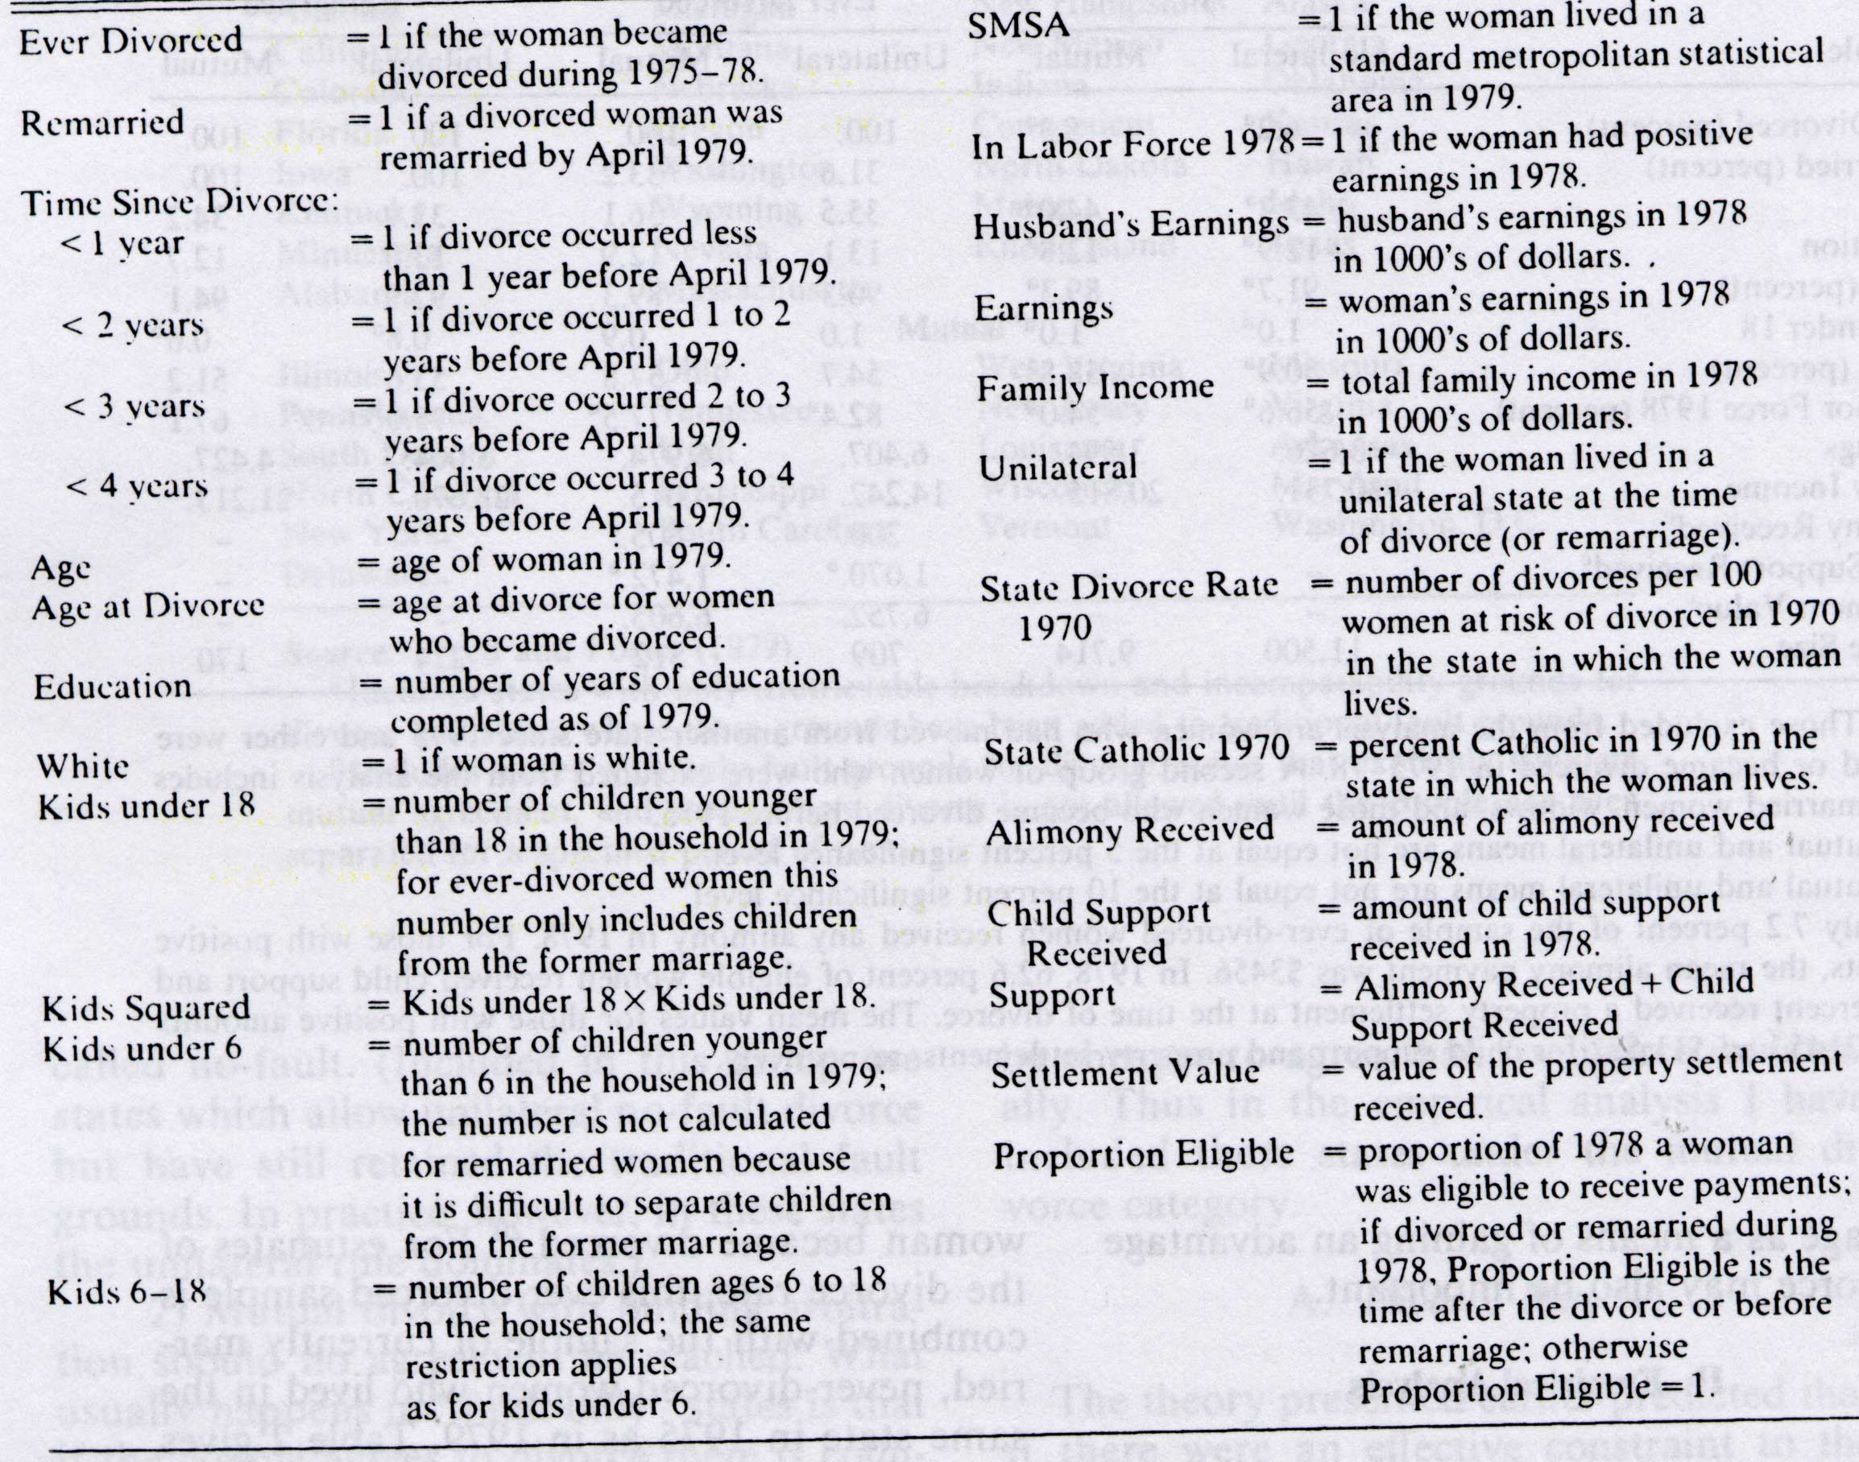

Table 2. Regression Results, Peters (1986.)

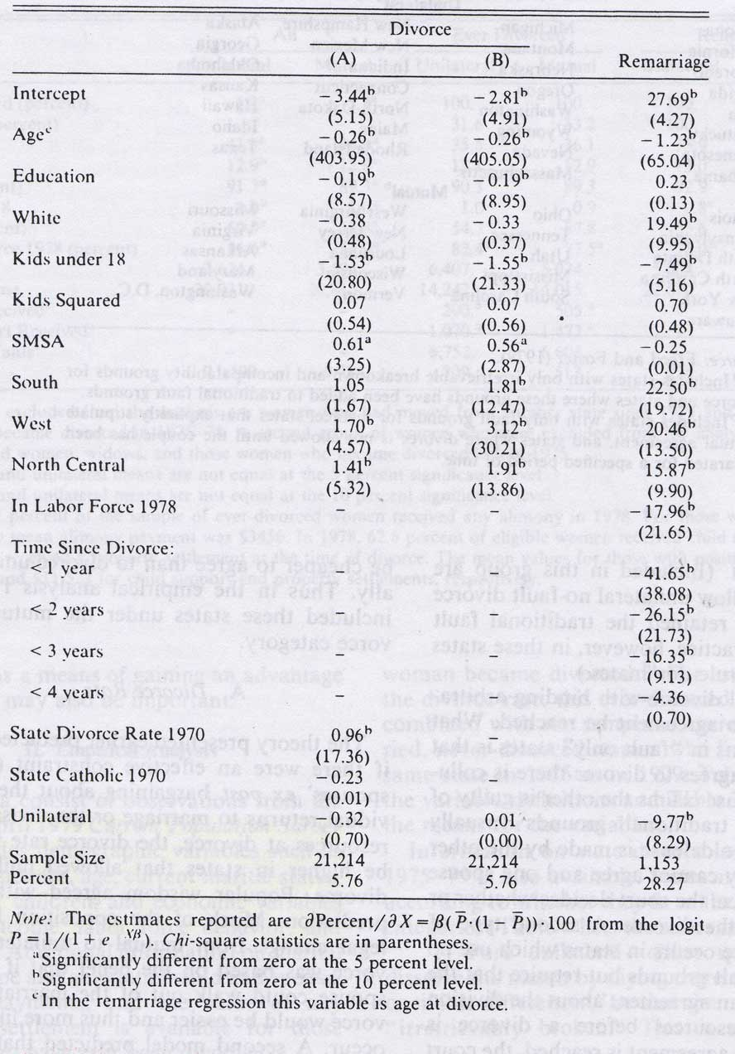

Table 3. Definition of Variables, Zelder (1993.)

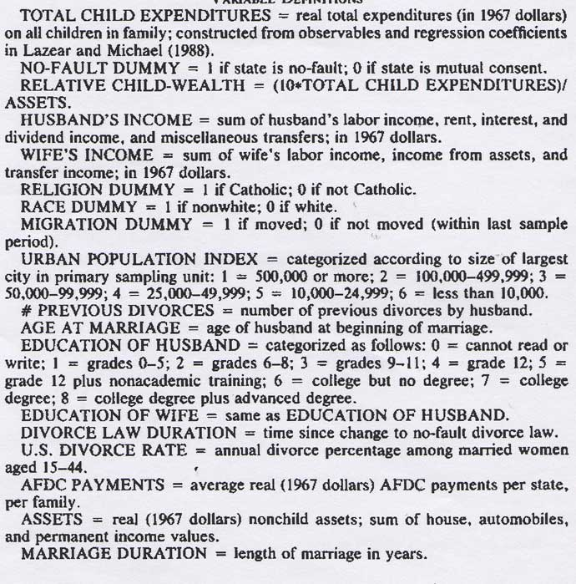

Table 4. Regression Results, Zelder (1993.)

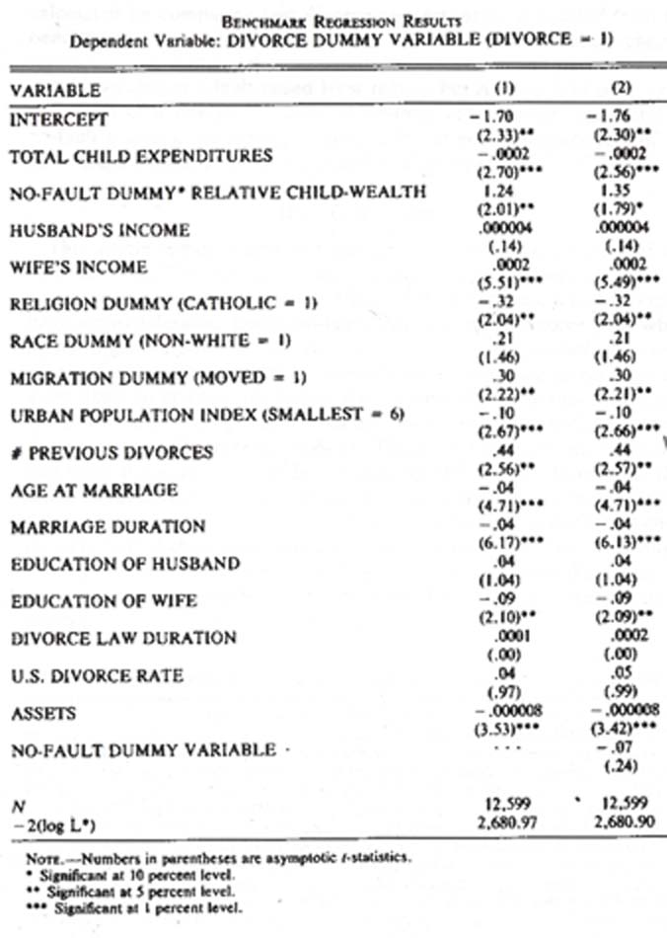

Table 5. Definition of Variables, Brinig & Buckley (1998.)

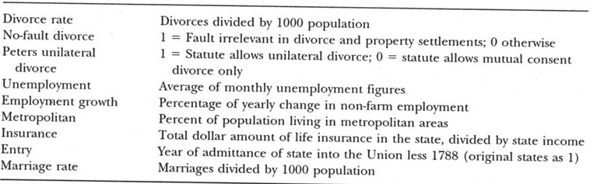

Table 6. Regression Results, Brinig & Buckley (1998.)

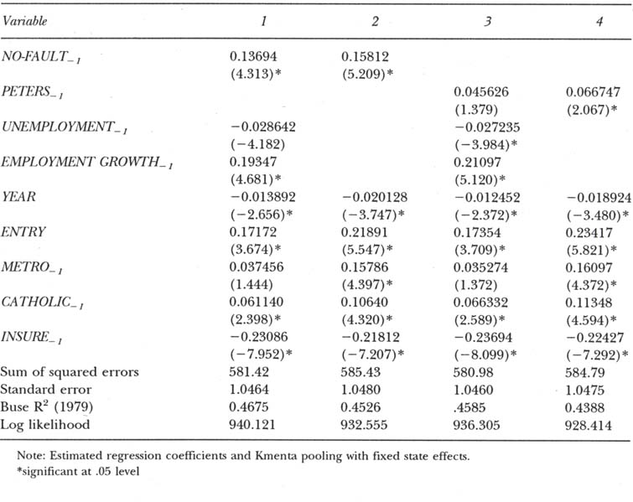

Table 7. Regression Results, Friedberg (1998.)

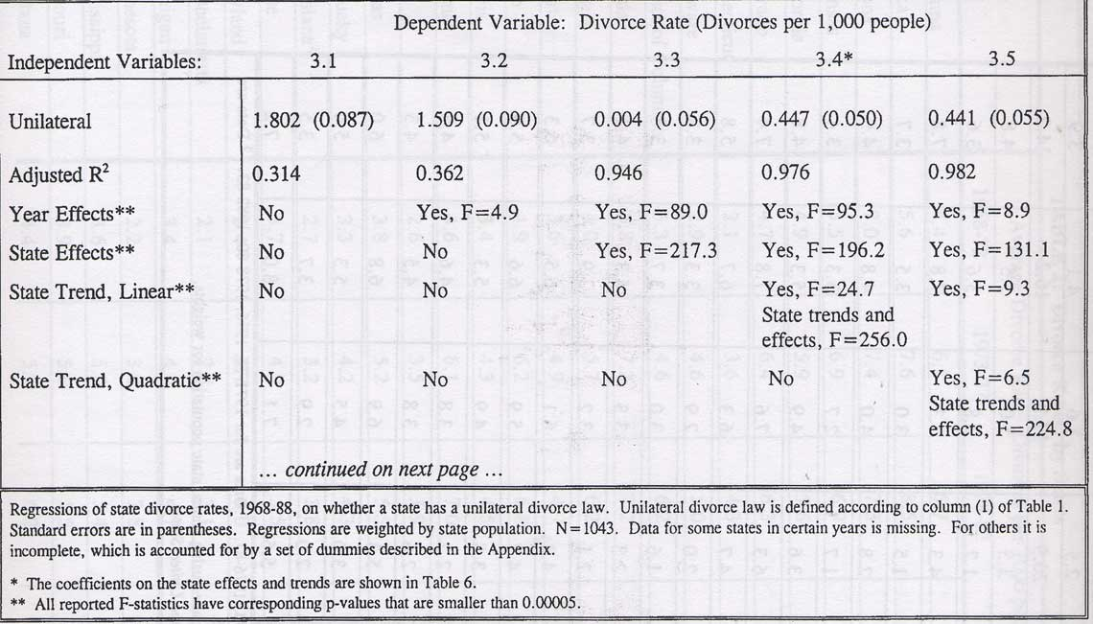

Table 8. Different Types of Unilateral Divorce, Friedberg (1998.)

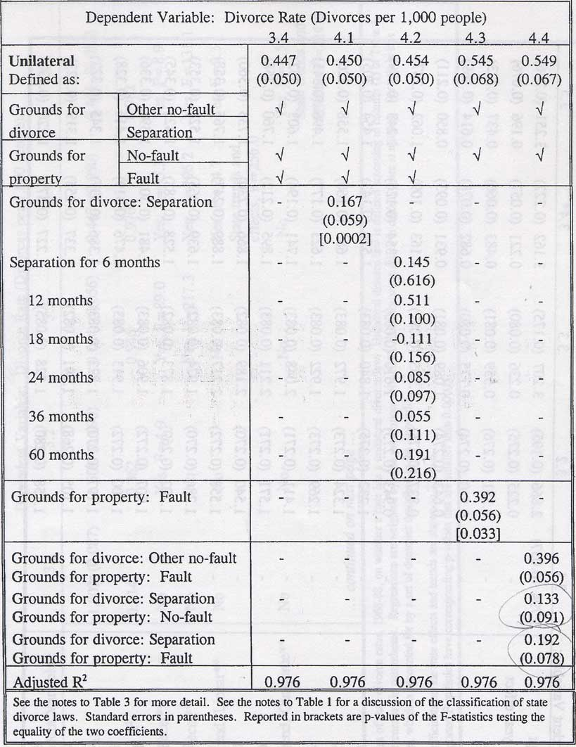

Table 9. Regression Results for Divorce Settlements, Peters (1986.)
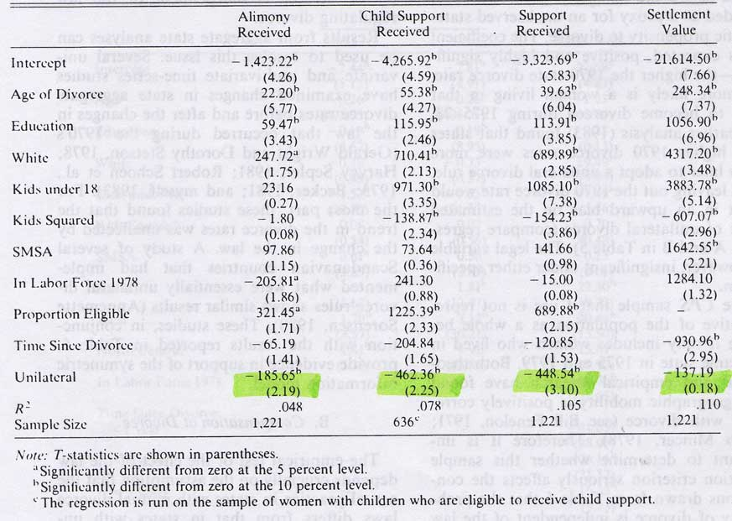

Wealth in children was not directly measured in PSID and the data was obtained from the analysis of Edward Lazear and Robert Michael (1988) “Allocation of Income within the Household”.
Marital property refers usually to tangible property acquired by the couple during the marriage.

